

**TAYYABA REHMAN**

**49690**

**OPERATING SYSTEM LAB**

**LAB 7**

**Question 01**

What would be the result of the following commands. Understand that is

* **cat filename > new**

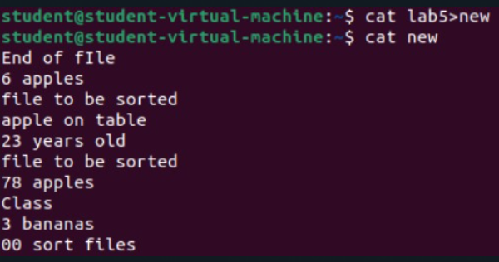

•This command reads the contents of lab5 and writes them into a new file called new.

•If new already exists, its content will be replaced with the content of lab5.

* **who > new**

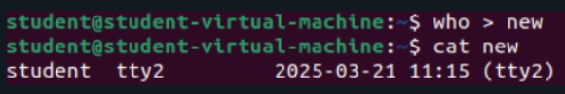

•The who command lists all users currently logged into the system.

•The output is redirected to the file new, replacing any previous content in new.

* **ls | sort –r**

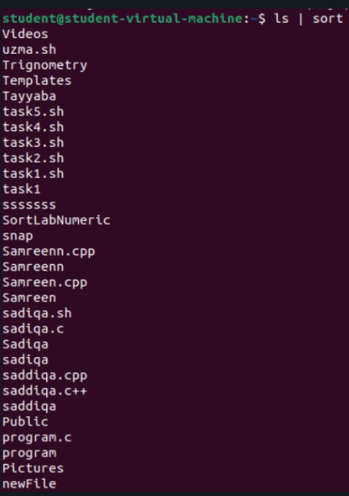

•ls lists all files and directories in the current directory.

•The output is then sent (piped) to sort -r, which sorts the list in reverse order.

•The sorted list is displayed on the screen.

* **ls | sort -r >> new**

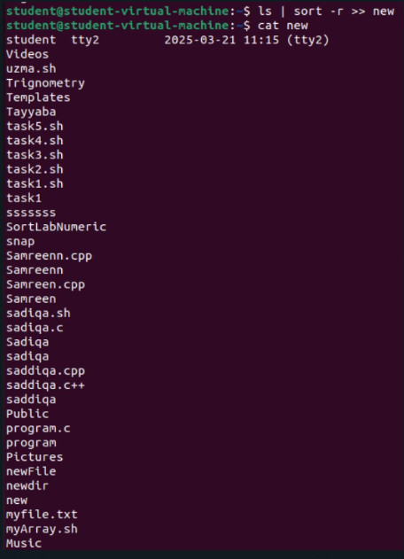

•Similar to the previous command, this lists files and sorts them in reverse order.

•However, the >> new part means the sorted output is appended to the file new instead of replacing its content.

**Question 02**

**Write a command that does the following:**

1. Sorts the contents of **fruits.txt** in alphabetical order.

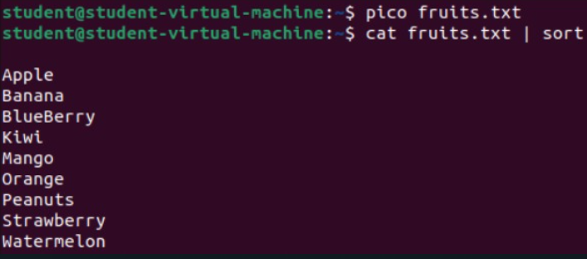

1. Filters the sorted output to only display fruits that contain the substring "ap".



**Question 03**

Define streams, redirection and pipes with one example of each in your own words.

* **Streams:**

Streams are the flow of data in a Linux system, used for input and output operations. There are three main types:

* **Standard Input (stdin)** → Takes input from the keyboard (0).
* **Standard Output (stdout)** → Displays output on the terminal (1).
* **Standard Error (stderr)** → Shows error messages (2).

**Example:**

cat < file.txt

This command takes input from file.txt (stdin) and displays its content.

* **Redirection:**

Redirection is used to send output from one command to a file or take input from a file instead of the keyboard.

**Example:**

ls > files.txt

This command saves the list of files in files.txt instead of displaying them on the screen.

* **Pipes:**

A pipe (|) is used to send the output of one command as input to another command.

**Example:**

ls | sort

This command first lists files using ls, then sorts them alphabetically using sort.